**WEEK – 4(Additional HandsOn)**

**Spring REST using Spring Boot 3**

**3. spring-rest-handson**

**1.Problem Statement - Display Employee List and Edit Employee form using RESTful Web Service.**

**<**project xmlns="http://maven.apache.org/POM/4.0.0" ...>

<modelVersion>4.0.0</modelVersion>

<groupId>com.cognizant</groupId>

<artifactId>employee-rest-service</artifactId>

<version>0.0.1-SNAPSHOT</version>

<packaging>jar</packaging>

<name>employee-rest-service</name>

<description>Spring Boot REST app using XML config</description>

<properties>

<java.version>17</java.version>

<spring.boot.version>3.1.2</spring.boot.version>

</properties>

<dependencies>

<!-- Spring Boot Web -->

<dependency>

<groupId>org.springframework.boot</groupId>

<artifactId>spring-boot-starter-web</artifactId>

</dependency>

<!-- For loading applicationContext.xml -->

<dependency>

<groupId>org.springframework</groupId>

<artifactId>spring-context</artifactId>

</dependency>

</dependencies>

<build>

<plugins>

<!-- Spring Boot Plugin -->

<plugin>

<groupId>org.springframework.boot</groupId>

<artifactId>spring-boot-maven-plugin</artifactId>

</plugin>

</plugins>

</build>

</project>

package com.cognizant.model;

public class Employee {

private int id;

private String name;

// Constructors

public Employee() {}

public Employee(int id, String name) {

this.id = id;

this.name = name;

}

// Getters and setters

public int getId() {

return id;

}

public void setId(int id) {

this.id = id;

}

public String getName() {

return name;

}

public void setName(String name) {

this.name = name;

}

}

package com.cognizant.controller;

import com.cognizant.model.Employee;

import org.springframework.beans.factory.annotation.Autowired;

import org.springframework.context.ApplicationContext;

import org.springframework.web.bind.annotation.GetMapping;

import org.springframework.web.bind.annotation.RequestMapping;

import org.springframework.web.bind.annotation.RestController;

import java.util.List;

@RestController

@RequestMapping("/api")

public class EmployeeController {

@Autowired

private ApplicationContext context;

@GetMapping("/employees")

public List<Employee> getAllEmployees() {

return (List<Employee>) context.getBean("employeeList");

}

}

package com.cognizant;

import org.springframework.boot.SpringApplication;

import org.springframework.boot.autoconfigure.SpringBootApplication;

import org.springframework.context.annotation.ImportResource;

@SpringBootApplication

@ImportResource("classpath:applicationContext.xml")

public class EmployeeRestServiceApplication {

public static void main(String[] args) {

SpringApplication.run(EmployeeRestServiceApplication.class, args);

}

}

<?xml version="1.0" encoding="UTF-8"?>

<beans xmlns="http://www.springframework.org/schema/beans"

xmlns:xsi="http://www.w3.org/2001/XMLSchema-instance"

xsi:schemaLocation="

http://www.springframework.org/schema/beans

https://www.springframework.org/schema/beans/spring-beans.xsd">

<bean id="employee1" class="com.cognizant.model.Employee">

<property name="id" value="1"/>

<property name="name" value="John"/>

</bean>

<bean id="employee2" class="com.cognizant.model.Employee">

<property name="id" value="2"/>

<property name="name" value="Jane"/>

</bean>

<bean id="employeeList" class="java.util.ArrayList">

<constructor-arg>

<list>

<ref bean="employee1"/>

<ref bean="employee2"/>

</list>

</constructor-arg>

</bean>

</beans>

**OUTPUT:**

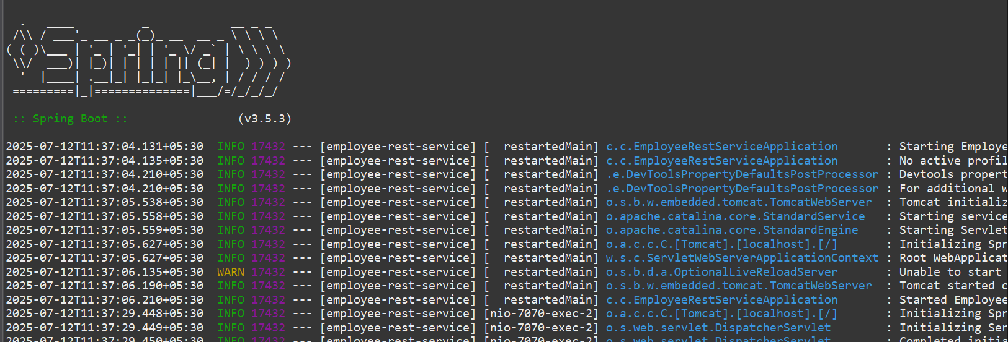

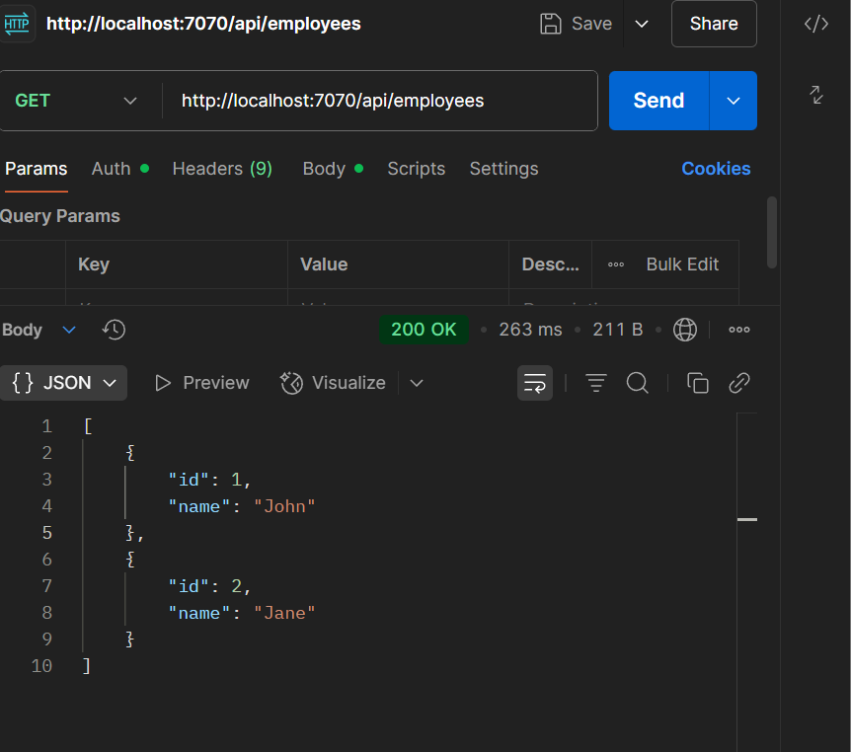

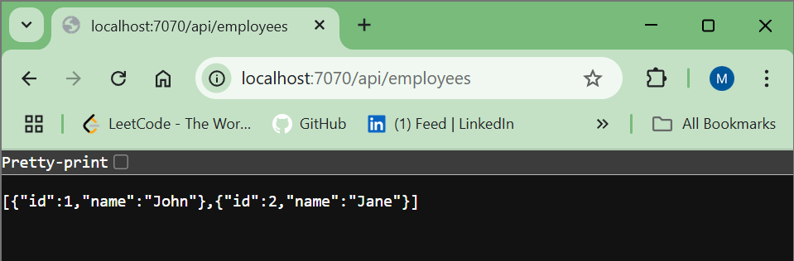

**2. Create static employee list data using spring xml configuration .**

// EmployeeRestServiceApplication.java

package com.cognizant;

import org.springframework.boot.SpringApplication;

import org.springframework.boot.autoconfigure.SpringBootApplication;

@SpringBootApplication

public class EmployeeRestServiceApplication {

public static void main(String[] args) {

SpringApplication.run(EmployeeRestServiceApplication.class, args);

}

}

// Employee.java

package com.cognizant.model;

import java.util.Date;

import java.util.List;

public class Employee {

private int id;

private String name;

private double salary;

private boolean permanent;

private Date dateOfBirth;

private Department department;

private List<Skill> skills;

public Employee() {

}

public Employee(int id, String name, double salary, boolean permanent, Date dateOfBirth, Department department, List<Skill> skills) {

this.id = id;

this.name = name;

this.salary = salary;

this.permanent = permanent;

this.dateOfBirth = dateOfBirth;

this.department = department;

this.skills = skills;

}

// Getters and setters omitted for brevity

// Generate them using your IDE or Lombok

}

// Department.java

package com.cognizant.model;

public class Department {

private int id;

private String name;

public Department() {

}

public Department(int id, String name) {

this.id = id;

this.name = name;

}

// Getters and setters

public int getId() { return id; }

public void setId(int id) { this.id = id; }

public String getName() { return name; }

public void setName(String name) { this.name = name; }

}

// Skill.java

package com.cognizant.model;

public class Skill {

private String name;

public Skill() {}

public Skill(String name) {

this.name = name;

}

public String getName() { return name; }

public void setName(String name) { this.name = name; }

}

// EmployeeDao.java

package com.cognizant.dao;

import com.cognizant.model.*;

import org.springframework.stereotype.Repository;

import java.text.SimpleDateFormat;

import java.util.*;

@Repository

public class EmployeeDao {

private List<Employee> employeeList = new ArrayList<>();

public EmployeeDao() {

try {

SimpleDateFormat sdf = new SimpleDateFormat("yyyy-MM-dd");

Department dept = new Department(101, "IT");

List<Skill> skills = Arrays.asList(new Skill("Java"), new Skill("Spring"));

Employee emp = new Employee(1, "John Doe", 50000, true, sdf.parse("1990-05-15"), dept, skills);

employeeList.add(emp);

} catch (Exception e) {

e.printStackTrace();

}

}

public List<Employee> getAllEmployees() {

return employeeList;

}

public void addEmployee(Employee employee) {

employeeList.add(employee);

}

}

// EmployeeController.java

package com.cognizant.controller;

import com.cognizant.dao.EmployeeDao;

import com.cognizant.model.Employee;

import org.springframework.beans.factory.annotation.Autowired;

import org.springframework.http.HttpStatus;

import org.springframework.http.ResponseEntity;

import org.springframework.web.bind.annotation.*;

import java.util.List;

@RestController

public class EmployeeController {

@Autowired

private EmployeeDao employeeDao;

@GetMapping("/employees")

public List<Employee> getAllEmployees() {

return employeeDao.getAllEmployees();

}

@PostMapping("/employees")

public ResponseEntity<Employee> addEmployee(@RequestBody Employee employee) {

employeeDao.addEmployee(employee);

return new ResponseEntity<>(employee, HttpStatus.CREATED);

}

}

**OUTPUT:**

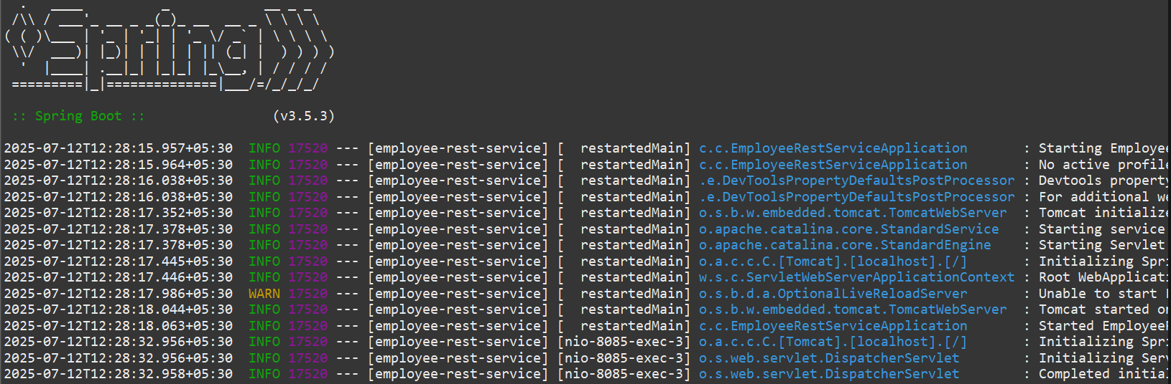

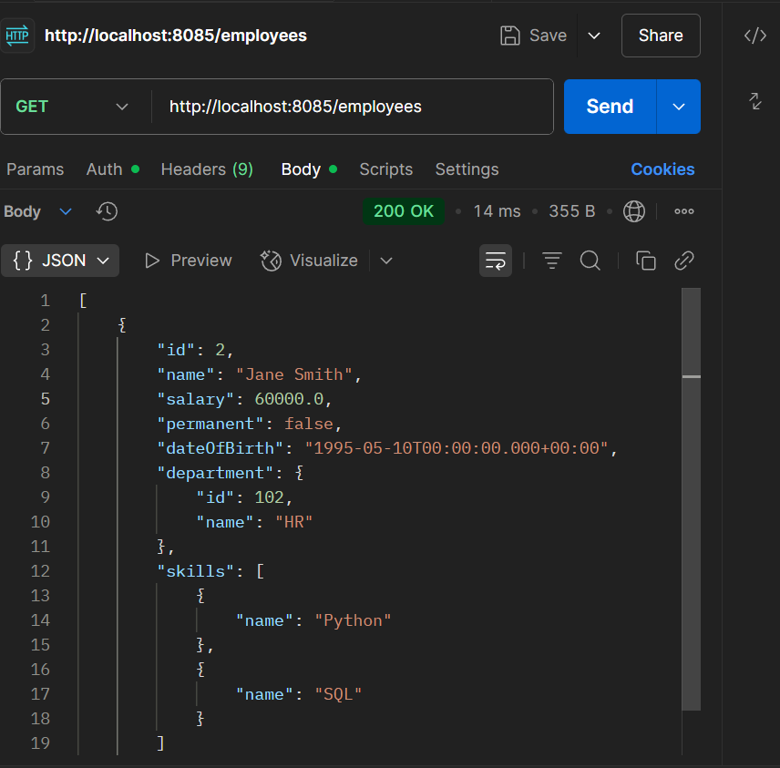

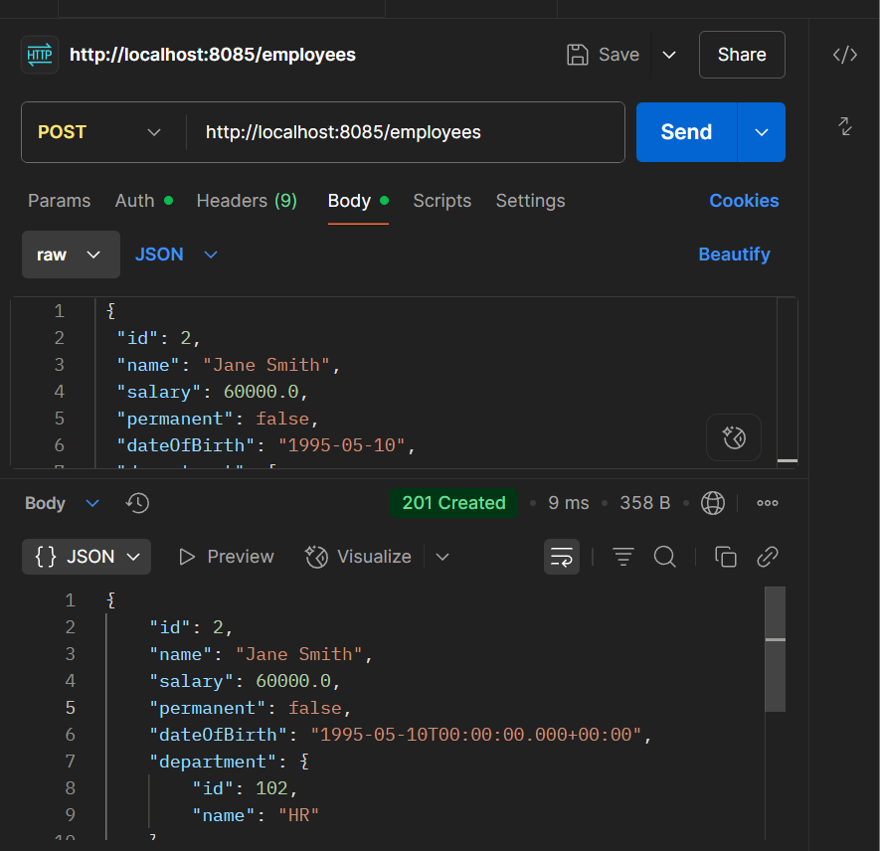

**3. Create REST service to gets all employees .**

<project xmlns="http://maven.apache.org/POM/4.0.0" ...>

<modelVersion>4.0.0</modelVersion>

<groupId>com.cognizant</groupId>

<artifactId>employee-rest-service</artifactId>

<version>0.0.1-SNAPSHOT</version>

<name>Employee REST Service</name>

<description>Spring Boot REST application for employees</description>

<packaging>jar</packaging>

<parent>

<groupId>org.springframework.boot</groupId>

<artifactId>spring-boot-starter-parent</artifactId>

<version>3.2.5</version>

</parent>

<dependencies>

<dependency>

<groupId>org.springframework.boot</groupId>

<artifactId>spring-boot-starter-web</artifactId>

</dependency>

<dependency>

<groupId>org.springframework</groupId>

<artifactId>spring-context</artifactId>

</dependency>

<dependency>

<groupId>com.fasterxml.jackson.core</groupId>

<artifactId>jackson-databind</artifactId>

</dependency>

</dependencies>

<properties>

<java.version>17</java.version>

</properties>

</project>

<beans xmlns="http://www.springframework.org/schema/beans"

xmlns:xsi="http://www.w3.org/2001/XMLSchema-instance"

xsi:schemaLocation="http://www.springframework.org/schema/beans

https://www.springframework.org/schema/beans/spring-beans.xsd">

<bean id="employeeDao" class="com.cognizant.dao.EmployeeDao">

<property name="employeeList">

<list>

<bean class="com.cognizant.model.Employee">

<property name="id" value="1"/>

<property name="name" value="John Doe"/>

<property name="salary" value="50000"/>

<property name="permanent" value="true"/>

<property name="dateOfBirth" value="1990-01-01"/>

<property name="department">

<bean class="com.cognizant.model.Department">

<property name="id" value="101"/>

<property name="name" value="IT"/>

</bean>

</property>

<property name="skills">

<list>

<bean class="com.cognizant.model.Skill">

<property name="name" value="Java"/>

</bean>

<bean class="com.cognizant.model.Skill">

<property name="name" value="Spring"/>

</bean>

</list>

</property>

</bean>

</list>

</property>

</bean>

</beans>

package com.cognizant.config;

import org.springframework.context.annotation.Configuration;

import org.springframework.context.annotation.ImportResource;

@Configuration

@ImportResource("classpath:employee.xml")

public class AppConfig {

}

package com.cognizant;

import org.springframework.boot.SpringApplication;

import org.springframework.boot.autoconfigure.SpringBootApplication;

@SpringBootApplication

public class EmployeeRestServiceApplication {

public static void main(String[] args) {

SpringApplication.run(EmployeeRestServiceApplication.class, args);

}

}

package com.cognizant.model;

public class Department {

private int id;

private String name;

// Getters and Setters

public int getId() { return id; }

public void setId(int id) { this.id = id; }

public String getName() { return name; }

public void setName(String name) { this.name = name; }

}

package com.cognizant.model;

public class Skill {

private String name;

// Getter & Setter

public String getName() { return name; }

public void setName(String name) { this.name = name; }

}

package com.cognizant.model;

import java.util.Date;

import java.util.List;

public class Employee {

private int id;

private String name;

private double salary;

private boolean permanent;

private Date dateOfBirth;

private Department department;

private List<Skill> skills;

// Getters and Setters

public int getId() { return id; }

public void setId(int id) { this.id = id; }

public String getName() { return name; }

public void setName(String name) { this.name = name; }

public double getSalary() { return salary; }

public void setSalary(double salary) { this.salary = salary; }

public boolean isPermanent() { return permanent; }

public void setPermanent(boolean permanent) { this.permanent = permanent; }

public Date getDateOfBirth() { return dateOfBirth; }

public void setDateOfBirth(Date dateOfBirth) { this.dateOfBirth = dateOfBirth; }

public Department getDepartment() { return department; }

public void setDepartment(Department department) { this.department = department; }

public List<Skill> getSkills() { return skills; }

public void setSkills(List<Skill> skills) { this.skills = skills; }

}

package com.cognizant.dao;

import com.cognizant.model.Employee;

import java.util.List;

public class EmployeeDao {

private List<Employee> employeeList;

public List<Employee> getAllEmployees() {

return employeeList;

}

// Setter for XML

public void setEmployeeList(List<Employee> employeeList) {

this.employeeList = employeeList;

}

}

package com.cognizant.service;

import com.cognizant.dao.EmployeeDao;

import com.cognizant.model.Employee;

import org.springframework.beans.factory.annotation.Autowired;

import org.springframework.stereotype.Service;

import org.springframework.transaction.annotation.Transactional;

import java.util.List;

@Service

public class EmployeeService {

@Autowired

private EmployeeDao employeeDao;

@Transactional

public List<Employee> getAllEmployees() {

return employeeDao.getAllEmployees();

}

}

package com.cognizant.controller;

import com.cognizant.model.Employee;

import com.cognizant.service.EmployeeService;

import org.springframework.beans.factory.annotation.Autowired;

import org.springframework.web.bind.annotation.*;

import java.util.List;

@RestController

public class EmployeeController {

@Autowired

private EmployeeService employeeService;

@GetMapping("/employees")

public List<Employee> getAllEmployees() {

return employeeService.getAllEmployees();

}

}

**OUTPUT:**

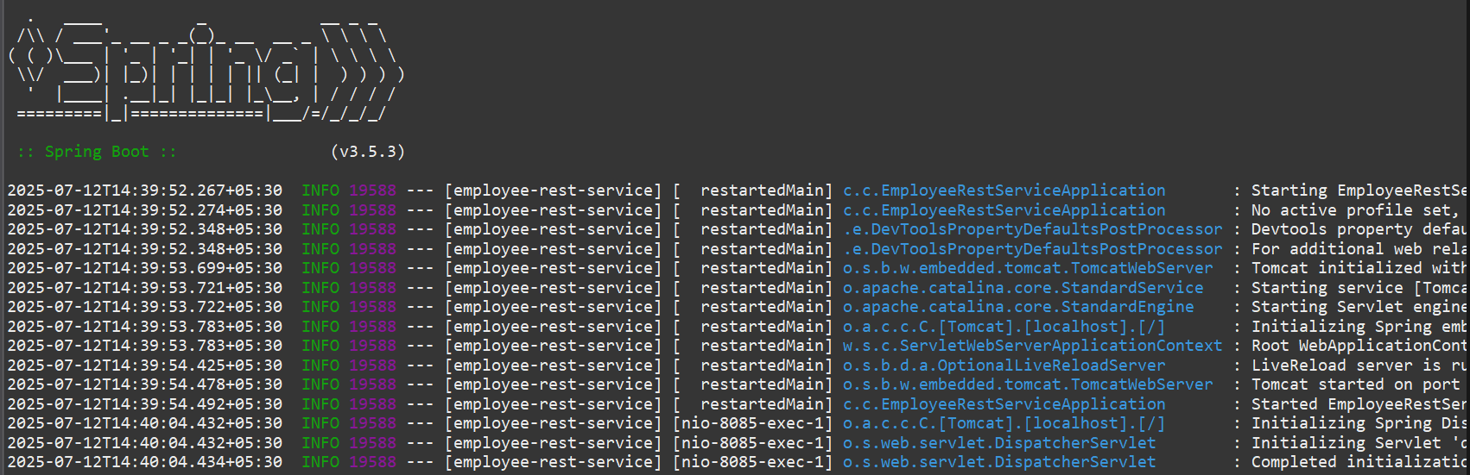

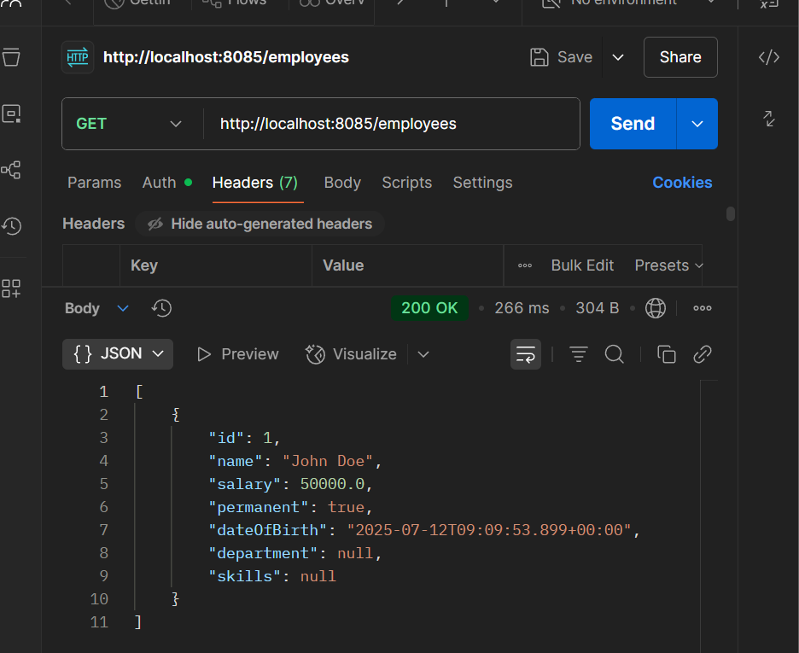

**4. Create REST service for department**

package com.cognizant.model;

public class Department {

private int id;

private String name;

public Department() {}

public Department(int id, String name) {

this.id = id;

this.name = name;

}

// Getters and Setters

public int getId() {

return id;

}

public void setId(int id) {

this.id = id;

}

public String getName() {

return name;

}

public void setName(String name) {

this.name = name;

}

}

package com.cognizant.dao;

import com.cognizant.model.Department;

import org.springframework.stereotype.Repository;

import java.util.ArrayList;

import java.util.List;

@Repository

public class DepartmentDao {

private static List<Department> departmentList = new ArrayList<>();

static {

departmentList.add(new Department(1, "Human Resources"));

departmentList.add(new Department(2, "Finance"));

departmentList.add(new Department(3, "Engineering"));

departmentList.add(new Department(4, "Marketing"));

}

public List<Department> getAllDepartments() {

return departmentList;

}

}

package com.cognizant.service;

import com.cognizant.dao.DepartmentDao;

import com.cognizant.model.Department;

import org.springframework.beans.factory.annotation.Autowired;

import org.springframework.stereotype.Service;

import java.util.List;

@Service

public class DepartmentService {

@Autowired

private DepartmentDao departmentDao;

public List<Department> getAllDepartments() {

return departmentDao.getAllDepartments();

}

}

package com.cognizant.controller;

import com.cognizant.model.Department;

import com.cognizant.service.DepartmentService;

import org.springframework.beans.factory.annotation.Autowired;

import org.springframework.web.bind.annotation.*;

import java.util.List;

@RestController

@RequestMapping("/departments")

public class DepartmentController {

@Autowired

private DepartmentService departmentService;

@GetMapping

public List<Department> getAllDepartments() {

return departmentService.getAllDepartments();

}

}

package com.cognizant;

import org.springframework.boot.SpringApplication;

import org.springframework.boot.autoconfigure.SpringBootApplication;

@SpringBootApplication

public class OrmLearnApplication {

public static void main(String[] args) {

SpringApplication.run(OrmLearnApplication.class, args);

}

}

<?xml version="1.0" encoding="UTF-8"?>

<beans xmlns="http://www.springframework.org/schema/beans"

xmlns:xsi="http://www.w3.org/2001/XMLSchema-instance"

xsi:schemaLocation="http://www.springframework.org/schema/beans

http://www.springframework.org/schema/beans/spring-beans.xsd">

<bean id="departmentList" class="java.util.ArrayList">

<constructor-arg>

<list>

<bean class="com.cognizant.model.Department">

<property name="id" value="1" />

<property name="name" value="HR" />

</bean>

<bean class="com.cognizant.model.Department">

<property name="id" value="2" />

<property name="name" value="Tech" />

</bean>

</list>

</constructor-arg>

</bean>

</beans>

**OUTPUT:**

